**139. Setting up Child (Nested) Routes**

* -: We improved out app quite a bit.
* But the issue we have is that if you click on a server or a user, you load a brand new page.
* It would be nicer if it would load it next to this menu.
* So we need some nested routing.
* We can also see that in the app module, we kind of have some duplication here.

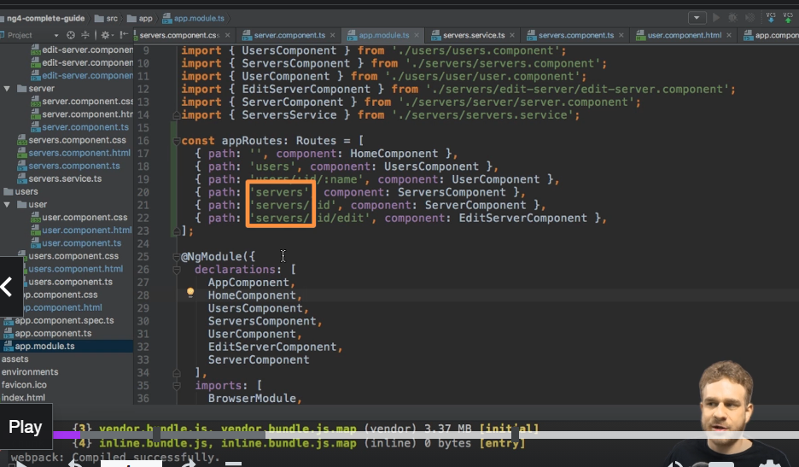

* All these routes here start with servers, and all these routes with users.
* So it would be nice to nest them and to have some child routes which all start with servers down here in this case, for example.
* Let's ***add such child routes.***
* To do this, I'll go to my servers component route, to the slash service route, and I'll add another property.
* Children.
* Children takes another array of routes, so now I can simply take my two other service routes here, and add them inside of this array as children.
* Now, servers should now be removed, because that is now always prepended at the beginning anyways.
* So we have to make sure to get rid of it here.
* And now we have just ID and ID edit.
* So this is now already better because now we group that together.
* It gives us more than this visual grouping here though.

* You notice that on the servers here, we have the servers component as the, well, component to be loaded still.
* **The question now is where will these server components be loaded**, then? Because that is yet another child route of our service component.
* And you can see that this is an issue.
* If we reload our app here, everything's working.
* If I click on test server, now we get an error.

* Because now the *error tells us that it cannot find an outlet to load our server component in.*
* And indeed it can't because the only route or outlet, the only hook in our code where it should load components, is in our app component here.

* ***Now that is reserved for all our routes on the top level.***
* So, slash nothing, slash users, users ID name, and servers.
* But the child routes of servers need a separate outlet, because they can't override the service component.
* Instead, they should be loaded nested into this service component.
* And that actually is the behavior we want.
* So we can quickly get there by going to the service component HTML file.
* And here where we load the edit page or the app server page.

Well here I will simply comment out all that code and instead add a **139. Setting up Child (Nested) Routes**

* -: We improved out app quite a bit.
* But the issue we have is that if you click on a server or a user, you load a brand new page.
* It would be nicer if it would load it next to this menu.
* So we need some nested routing.
* We can also see that in the app module, we kind of have some duplication here.

* All these routes here start with servers, and all these routes with users.
* So it would be nice to nest them and to have some child routes which all start with servers down here in this case, for example.
* Let's ***add such child routes.***
* To do this, I'll go to my servers component route, to the slash service route, and I'll add another property.
* Children.
* Children takes another array of routes, so now I can simply take my two other service routes here, and add them inside of this array as children.
* Now, servers should now be removed, because that is now always prepended at the beginning anyways.
* So we have to make sure to get rid of it here.
* And now we have just ID and ID edit.
* So this is now already better because now we group that together.
* It gives us more than this visual grouping here though.

* You notice that on the servers here, we have the servers component as the, well, component to be loaded still.
* **The question now is where will these server components be loaded**, then? Because that is yet another child route of our service component.
* And you can see that this is an issue.
* If we reload our app here, everything's working.
* If I click on test server, now we get an error.

* Because now the *error tells us that it cannot find an outlet to load our server component in.*
* And indeed it can't because the only route or outlet, the only hook in our code where it should load components, is in our app component here.

* ***Now that is reserved for all our routes on the top level.***
* So, slash nothing, slash users, users ID name, and servers.
* But the child routes of servers need a separate outlet, because they can't override the service component.
* Instead, they should be loaded nested into this service component.
* And that actually is the behavior we want.
* So we can quickly get there by going to the service component HTML file.
* And here where we load the edit page or the app server page.
* Well here I will simply comment out all that code and instead add a router outlet here.
* This now adds a new hook which will be used on all child routes off the route being loaded on the service component, which of course is our slash service route here.
* So all these child routes will be loaded in this router out of place now.
* So if we save this, and now we let this reload.
* You don't see anything here.
* But if I click a server, it's now loaded next to the menu because this is where we added our second router outlet.

* And this is how you can easily add child routes.
* Let's do the same for the user routes now.
* In the app module I'll add children here.
* So this property which takes an array of routes.
* And I only have one nested route here, but that's fine.
* So we'll add it here.
* Get rid of the users at the beginning.
* Just have slash, well, oh, and the ID and name, the two dynamic parameters, and load the user component.

* And now in my users component HTML file, I'll replace my app user here with another router outlet where all the user-related child routes, or the one user-related child route we have, will be loaded.
* So if we save this, you now see we load the user next to it, and that is why it is super important to dynamically update the ID and so on.

* Because the component wasn't exchanged, we were able to switch the loaded user while this old component, the user component, the single user component, was already loaded.
* And this is how you can implement child routing, nested routes, with this children property which then holds all the nested routes.
* router outlet here.
* This now adds a new hook which will be used on all child routes off the route being loaded on the service component, which of course is our slash service route here.
* So all these child routes will be loaded in this router out of place now.
* So if we save this, and now we let this reload.
* You don't see anything here.
* But if I click a server, it's now loaded next to the menu because this is where we added our second router outlet.
* And this is how you can easily add child routes.
* Let's do the same for the user routes now.
* In the app module I'll add children here.
* So this property which takes an array of routes.
* And I only have one nested route here, but that's fine.
* So we'll add it here.
* Get rid of the users at the beginning.
* Just have slash, well, oh, and the ID and name, the two dynamic parameters, and load the user component.
* And now in my users component HTML file, I'll replace my app user here with another router outlet where all the user-related child routes, or the one user-related child route we have, will be loaded.
* So if we save this, you now see we load the user next to it, and that is why it is super important to dynamically update the ID and so on.
* Because the component wasn't exchanged, we were able to switch the loaded user while this old component, the user component, the single user component, was already loaded.
* And this is how you can implement child routing, nested routes, with this children property which then holds all the nested routes.